**Instructor:** Yerasyl Amanbek

**Student:** Amir Yakubov

**Date:** 08.04.2021

**Part 1. Introduction to Microcontrollers and Electronics (20%)**  
  
**1.** Briefly describe (1 sentence) at least 8 components in Arduino board

|  |  |
| --- | --- |
| **Name** | **Description** |
| Power connector | Used to power the Arduino, accepts voltage from 7-12 V. |
| USB port | Also, to charge, and a way to "communicate" with our Arduino. |
| ATmega microcontroller | In short, the heart of Arduino. |
| Reset Button | The button resets the ATmega microcontroller. |
| 5V pin | Used to supply current. |
| GND pin | The place where all current loops end and the current returns to the battery. |
| Analog | Reads the value from the specified analog pin, used with analogRead(). |
| Digital pins | Used to read and write some components to others. |
| Power LED | Shows that Arduino is receiving energy. |
| Pin 13 LED | The only built-in drive in the Arduino board, has an LED and a resistor. |
| TX and RX LEDs | Determines if there is a connection between the computer and Arduino |

**2.** Select 8 electronic components and describe them (1 sentence), also explain how they can be used in projects (1 sentence).

|  |  |  |
| --- | --- | --- |
| **Name** | **Description** | **Use in projects** |
| LEDs | Lights up when current passes through it. | For example, make a lighthouse, glowing clock or a picture, and other things. |
| Sound sensor | Analog models allow audio recognition and processing. | Turning on and off the light with a clap or some set sound. |
| Pushbuttons | Switches that close  a circuit when the button pressed. | It can be used as a switch, for example to turn on a light. |
| Piezo | Can create noise or a certain melody, also detect vibration. | Play the melody of the song. |
| Photoresistor | Resistor that changes resistance depending on the light incident on its surface. | Can be used, for example, in some supermarket to play music during the day or announcement. |
| Temperature sensor | It changes voltage depending on temperature. | Check the temperature in the room and set the desired one, for example, in the aquarium. |
| PIR | The sensor allows you to track the movement of objects that emit heat in a closed area. | Turn on alarm when motion is detected. Turn on the light at the entrance. |
| Current sensor | Measuring and monitoring flowing current. | For detecting non-working electrical appliances. |

**Part 2. Project 5 from Arduino Projects Book.** **(40%)**  
*Build project 5 from Arduino Projects Book in Tinkercad.*

**1.** Provide screenshot of the circuit

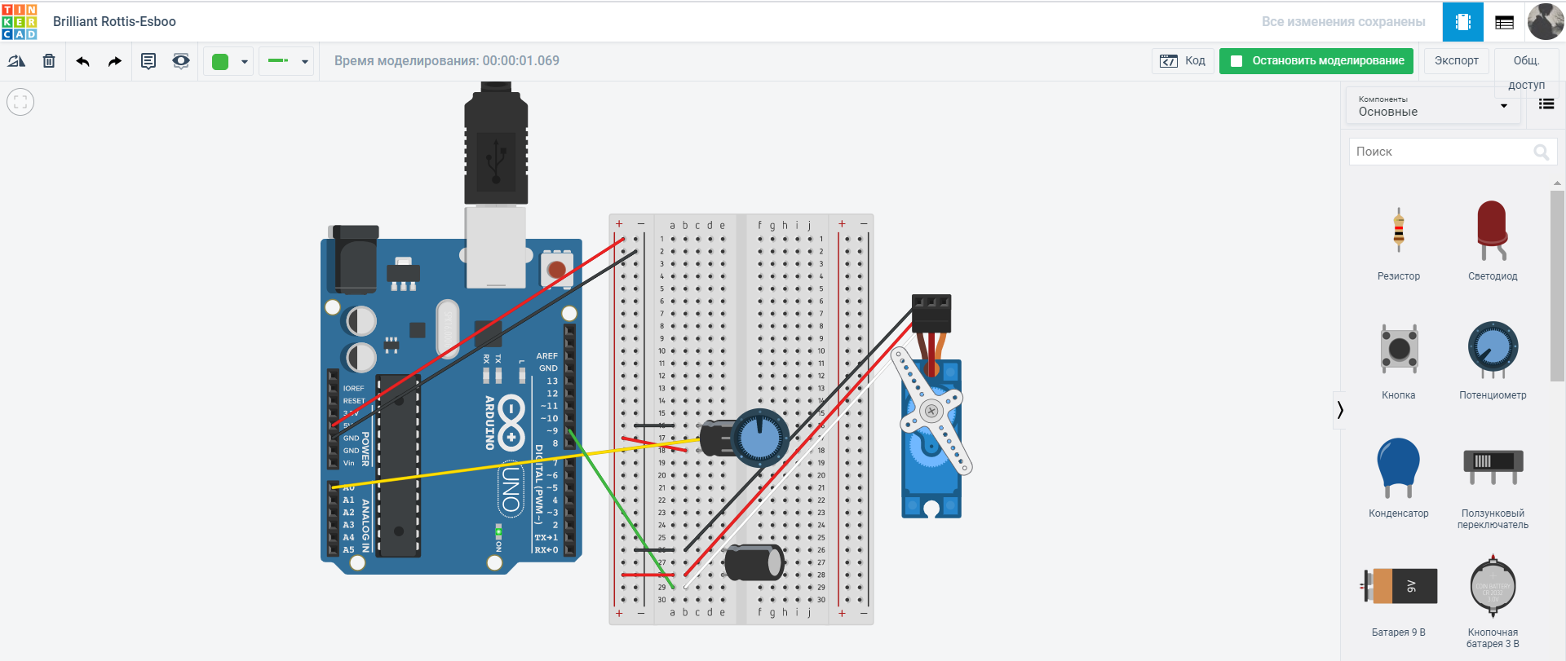

**2.** Record voltage across servo-motor

a) when potentiometer resistance is high

|  |  |
| --- | --- |
| servo-motor | Voltage |
| Legs (+ / -) (red / black) | 5.00 V |
| Legs (pulse / -) (white /black) | 700 mV |

b) when potentiometer resistance is low

|  |  |
| --- | --- |
| servo-motor | Voltage |
| Legs (+ / -) (red / black) | 5.00 V |
| Legs (pulse / -) (white /black) | 100 mV |

Your observation on behaviour of servo-motor when potentiometer value changes:

By changing the potentiometer values, the arrow starts to move counterclockwise. Also, having connected a multimeter, I noticed that by increasing the angle and value of the potentiometer, the pulse changes, voltage increases.  
  
**3.** Explain how current from 5V source flows through the circuit.   
The 5V current flows in 2 ways at once. I will describe this following the layout I built.

1) It flows and passes from plus to b18, further into the capacitor, then into the potentiometer and returns to ground.

2) The current flows from plus to a28, further into the capacitor, and the servo-motor, and returns to ground.  
  
**4.** Provide codes with comments.

#include <Servo.h> // import library to use servo

Servo myServo; //create an object to refer to the servo

int const potPin = A0; // constant for the output where the potentiometer is installed

int potVal; // variables to hold the analog input value

int angle; // angle we want the servo to move to

void setup() { // to tell the Arduino what pin our servo is attached to

myServo.attach(9);

Serial.begin(9600);

}

void loop() { // read the analog input and print out the value to the serial monitor

potVal = analogRead(potPin); // initialization

Serial.print("potVal: "); // output of this inscription

Serial.print(potVal); // output of this value

angle = map(potVal, 0, 1023, 0, 179); //change values ​​between 0-1023 to values ​​from 0 to 179

Serial.print(", angle: "); // output of this inscription

Serial.println(angle); // output of this value

myServo.write(angle); //moves the motor to the specified angle

delay(15); // the servo has time to change position

}

**5.** Provide link to the project  
<https://www.tinkercad.com/things/cIIdQOmMcqC>

**Part 3. Project 6 (modified) from Arduino Projects Book. (40%)**

*Build project 6 from Arduino Projects Book in Tinkercad.*

***Modify the project:*** *remove photoresistor and clear the code. Write new code, in which* ***PIEZO*** *will play a song (melody) of your choice. E.g., Star Wars theme, happy birthday, Game of thrones theme, etc.*

1. Provide screenshot of the modified circuit.

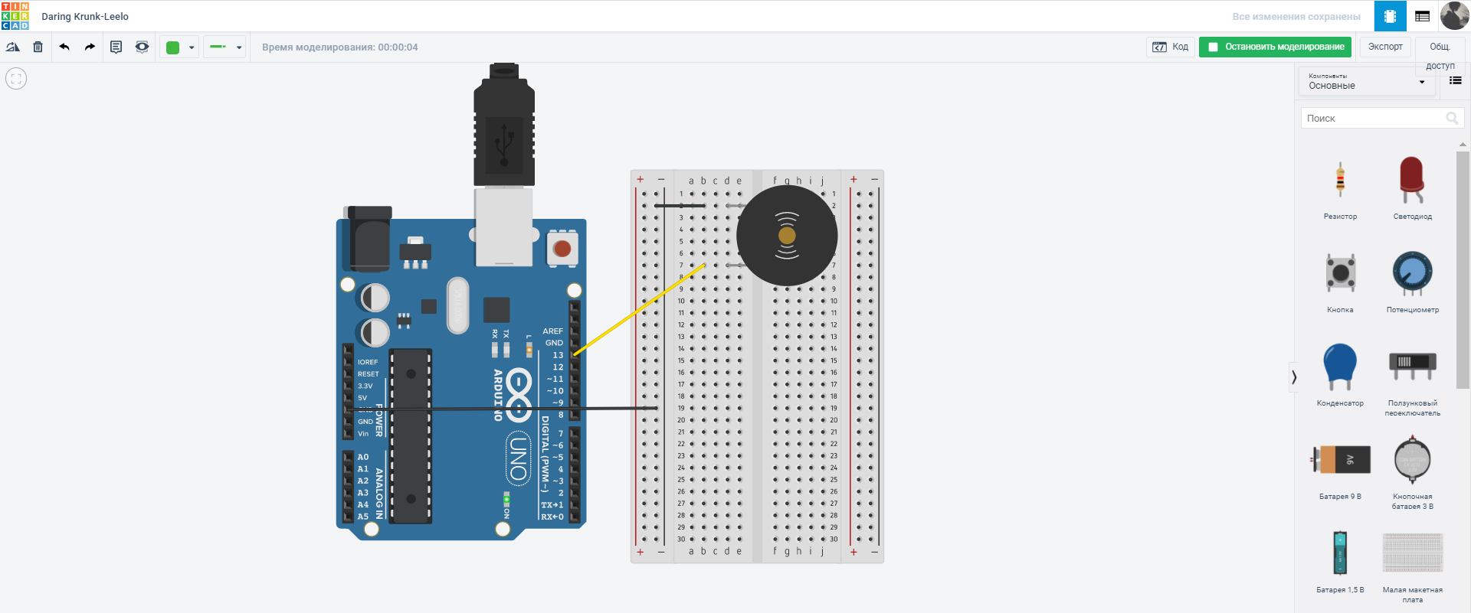

1. Explain what is PWM?

PWM is a method of reducing the average power delivered by an electrical signal, by effectively chopping it up into discrete parts. PWM rapidly turns the output pin high and low over a fixed period. The change happens faster than the human eye can see.

1. Explain **tone()** function

Tone() is used to play a specific sound. You can specify the duration, if you do not do this, it will continue until the battery runs out or the noTone () function is called, Connects to a piezo or other speaker. It cannot reproduce several sounds at the same time, at the moment there is only one.

1. Explain **map()** function

The map function is intended to change one range of values into another range of values and a common use is to read an analogue input and change the output to a byte so the output would be from 0 to 255.

1. Provide codes with comments

//below is a library of notes

#define NOTE_B0 31

#define NOTE_C1 33

#define NOTE_CS1 35

#define NOTE_D1 37

#define NOTE_DS1 39

#define NOTE_E1 41

#define NOTE_F1 44

#define NOTE_FS1 46

#define NOTE_G1 49

#define NOTE_GS1 52

#define NOTE_A1 55

#define NOTE_AS1 58

#define NOTE_B1 62

#define NOTE_C2 65

#define NOTE_CS2 69

#define NOTE_D2 73

#define NOTE_DS2 78

#define NOTE_E2 82

#define NOTE_F2 87

#define NOTE_FS2 93

#define NOTE_G2 98

#define NOTE_GS2 104

#define NOTE_A2 110

#define NOTE_AS2 117

#define NOTE_B2 123

#define NOTE_C3 131

#define NOTE_CS3 139

#define NOTE_D3 147

#define NOTE_DS3 156

#define NOTE_E3 165

#define NOTE_F3 175

#define NOTE_FS3 185

#define NOTE_G3 196

#define NOTE_GS3 208

#define NOTE_A3 220

#define NOTE_AS3 233

#define NOTE_B3 247

#define NOTE_C4 262

#define NOTE_CS4 277

#define NOTE_D4 294

#define NOTE_DS4 311

#define NOTE_E4 330

#define NOTE_F4 349

#define NOTE_FS4 370

#define NOTE_G4 392

#define NOTE_GS4 415

#define NOTE_A4 440

#define NOTE_AS4 466

#define NOTE_B4 494

#define NOTE_C5 523

#define NOTE_CS5 554

#define NOTE_D5 587

#define NOTE_DS5 622

#define NOTE_E5 659

#define NOTE_F5 698

#define NOTE_FS5 740

#define NOTE_G5 784

#define NOTE_GS5 831

#define NOTE_A5 880

#define NOTE_AS5 932

#define NOTE_B5 988

#define NOTE_C6 1047

#define NOTE_CS6 1109

#define NOTE_D6 1175

#define NOTE_DS6 1245

#define NOTE_E6 1319

#define NOTE_F6 1397

#define NOTE_FS6 1480

#define NOTE_G6 1568

#define NOTE_GS6 1661

#define NOTE_A6 1760

#define NOTE_AS6 1865

#define NOTE_B6 1976

#define NOTE_C7 2093

#define NOTE_CS7 2217

#define NOTE_D7 2349

#define NOTE_DS7 2489

#define NOTE_E7 2637

#define NOTE_F7 2794

#define NOTE_FS7 2960

#define NOTE_G7 3136

#define NOTE_GS7 3322

#define NOTE_A7 3520

#define NOTE_AS7 3729

#define NOTE_B7 3951

#define NOTE_C8 4186

#define NOTE_CS8 4435

#define NOTE_D8 4699

#define NOTE_DS8 4978

int a = 13; //buzzer

void setup() { // to tell the Arduino what pin our servo is attached to

pinMode(a, OUTPUT);

}

void loop() { //repeat the function

GameOfThrones();

}

void GameOfThrones() { //song play function by notes

tone(a, NOTE_G4);

delay(500);

noTone(a);

tone(a, NOTE_C4);

delay(500);

noTone(a);

tone(a, NOTE_DS4);

delay(250);

noTone(a);

tone(a, NOTE_F4);

delay(250);

noTone(a);

tone(a, NOTE_D4);

delay(500);

noTone(a);

tone(a, NOTE_G3);

delay(500);

noTone(a);

tone(a, NOTE_AS3);

delay(250);

noTone(a);

tone(a, NOTE_C4);

delay(250);

noTone(a);

tone(a, NOTE_D4);

delay(1500);

noTone(a);

tone(a, NOTE_F4);

delay(1500);

noTone(a);

tone(a, NOTE_AS3);

delay(1000);

noTone(a);

tone(a, NOTE_DS4);

delay(250);

noTone(a);

tone(a, NOTE_D4);

delay(250);

noTone(a);

tone(a, NOTE_F4);

delay(1000);

noTone(a);

tone(a, NOTE_AS3);

delay(1000);

noTone(a);

tone(a, NOTE_DS4);

delay(250);

noTone(a);

tone(a, NOTE_D4);

delay(250);

noTone(a);

tone(a, NOTE_C4);

delay(500);

noTone(a);

tone(a, NOTE_GS3);

delay(250);

noTone(a);

tone(a, NOTE_AS3);

delay(250);

noTone(a);

tone(a, NOTE_C4);

delay(500);

noTone(a);

tone(a, NOTE_F3);

delay(500);

noTone(a);

tone(a, NOTE_G4);

delay(1000);

noTone(a);

tone(a, NOTE_C4);

delay(1000);

noTone(a);

tone(a, NOTE_DS4);

delay(250);

noTone(a);

tone(a, NOTE_F4);

delay(250);

noTone(a);

tone(a, NOTE_G4);

delay(1000);

noTone(a);

tone(a, NOTE_C4);

delay(1000);

noTone(a);

tone(a, NOTE_DS4);

delay(250);

noTone(a);

tone(a, NOTE_F4);

delay(250);

noTone(a);

tone(a, NOTE_D4);

delay(500);

noTone(a);

tone(a, NOTE_G3);

delay(500);

noTone(a);

tone(a, NOTE_AS3);

delay(250);

noTone(a);

tone(a, NOTE_C4);

delay(250);

noTone(a);

tone(a, NOTE_D4);

delay(500);

noTone(a);

}

**6.** Provide link to the project

<https://www.tinkercad.com/things/klKq47QBL2b>